Final Project Design Phase
Computer Science - Week 11
Oct 3, 2026 - Version 0.0.4

For complete instructions and project ideas, refer to the assignment in Canvas. Specifically, review the final project requirements before you continue below. If you have not reviewed the project requirements in Canvas (you might have to go to the modules view and check the current or past week's content), you will not be able to properly complete the parts below. In addition, it may be helpful to review the information on this Drafter documentation page.

0) Project Planning and Preparation
Successful programmers spend time planning before they begin coding. After reviewing the project requirements, answer the following questions to help guide your design and development process.
- What concepts from class or previous assignments might help you complete this project? Which programming concepts (loops, conditionals, lists, classes, etc.) do you expect to use? What programming skills do you want to improve while completing this project?
My chemistry class is going to be critical for this project. I am going to need formulas and the knowledge of how to convert between molecules in a stoichiometric equation.

- Which parts of the project do you expect to be the easiest for you? The hardest? Why?
I expect the equations are going to be the easiest. The hardest part is going to be learning chempy, simply because I have never used it before. I am not sure how the coding itself is going to be.

- Even though you have not yet designed the final project, estimate which tasks will likely require the most time and effort? Which features or components should be implemented first?
I believe the initial reaction, balancing it, and keeping all the variables in mind is going to be the hardest.

- What distractions might interfere with your work and how will you minimize them? What resources will you need available while working? What questions, if any, do you still have about the assignment requirements?
Other homework is going to be the biggest distraction. I will either do the homework before, or start this on a day I have a lot of time on (Saturday). I need to learn chempy and I will be using ChatGPT to help me.

1) Site Diagram
Create a mock-up of your planned website. We suggest you make the mockup on paper, although you can also use software like PowerPoint or Slides to make a mockup. There is other design software that could also be used, but we strongly encourage you to keep it simple. Do not spend more than 15-30 minutes detailing the mock-up. Your goal should be to make a very quick and dirty diagram, to show that you have some kind of idea.

We recommend drawing each page as a rectangle, and laying out the text, buttons, and other components inside. Then, use arrows to indicate links between pages. Label each page the way you will name each function, and then put labels on the arrows to indicate what the button links. Also write down any parameters that should come into the pages.

In addition to the pages and routes, write down what fields your `State` will have, both their names and types. Think clearly about what data will need to be persistent across the entire website.

Add photo(s) or screenshot(s) of your website mock-up and labeled diagram on the next page.

(The state was changed to include more attributes below, and the Equation dataclass of broken up)
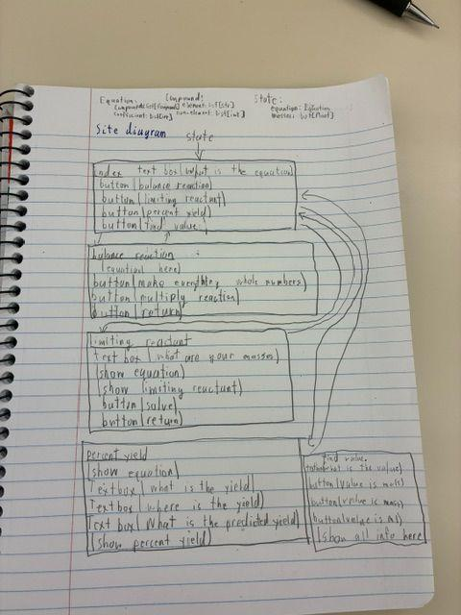

2) Implementing Requirements
This table should serve as a draft for how you will implement the requirements into your final project. You may change your ideas later on, but your final site must fulfill all the requirements.

Requirement | Implementation
Purpose/Functionality  A 1-2 sentence description of the purpose or functionality of your site | The Purpose of my program is to help me with future chemistry problems as a chemical engineer.
State Dataclass Attributes  Minimum of 4 attributes, one of which must be a list/dict of instances of your second dataclass.  Briefly describe each attribute, its type, and how it will be meaningfully modified throughout the site. | My state has a list of compounds (Compound), a list of coefficients (str), length of the reactants (int), length of the products (int) and a list of masses(str) [the base value I am going to use to calculate all the other values]. The compound dataclass has a list of elements(str) and the number of the element(int)
Second Dataclass  Your second dataclass, including its attributes, their types, and how they will be meaningfully modified (if they are modified) | Compound: This determines the chemical formulas needed (like molar mass and density)  - List of elements (str)  - List of numbers (int)  It will be modified based on the users inputs
Routes (minimum 7)  The names of your route functions | Index  Balance reaction  Limiting reactant  Find Limiting reactant (a different page than the limiting reactant)  Percent yield  Find percent yield (generates a different page than percent yield)  Find value  Error
Pages (minimum 5)  A brief description of the pages in your site | Index (The main page that sents the program to do different tasks)  Balance reaction (balances and saves the chemical equation)  Limiting reactant (shows a page and an input for the 2 or more masses)  Find Limiting reactant (displayes the limiting reactant)  Percent yield (a page that asks for the measured yield and where it is)  Find percent yield (shows the percent yield)  Find value (asks for a mass, mol, or ml. Returns all the masses compounds in the equation and saves them to the state)  Error (if there is a problem with the code, it returns this page)
User Input (minimum 3)  Description of user input components (TextBox, TextArea, CheckBox, or SelectBox) and their purposes  For more information on these input types, see Drafter Documentation. | Text box for mass input (3 of these will be in the program)  Textbox for Milliliters  Textbox for mols
If Statements (minimum 3)  Brief description of what will be evaluated in your if statements and how they will meaningfully change the logic of the site | One if statement will be used to determine if mols, ml, or mass was chosen for the find value.  One if statement will be used to help find the limiting reactant.  The final if statement will be used to  If statements will also be used as guards
Loop (minimum 1)  This loop must iterate over the list/dict of dataclass instances in your State attribute.  Description of this loop and why it is meaningful to the site | I will need many for loops to iterate over the state.

LLM Conversation
If you used an LLM in any part of this work, copy and paste every part of that conversation below. Otherwise, you may be given a zero for the assignment. Obviously, these words will not all be yours, and this is the exception to the requirement at the top of this assignment that all responses be in your own words. If you did not use an LLM to assist you in this assignment, simply say so below.
No LLM was used here.

Final Submission
When you are finished, download this file as a Word Document (docx) and upload the file to the appropriate assignment on Canvas.

